Subhradip Debnath  
Sec : A  
Roll : 19  
CSE Department  
Institute of Engineering and Management, Kolkata

Date : Wednesday, 2 September 2020

**Assignment -5**

1. Find the earliest start of all the nodes in the below Network Diagram –

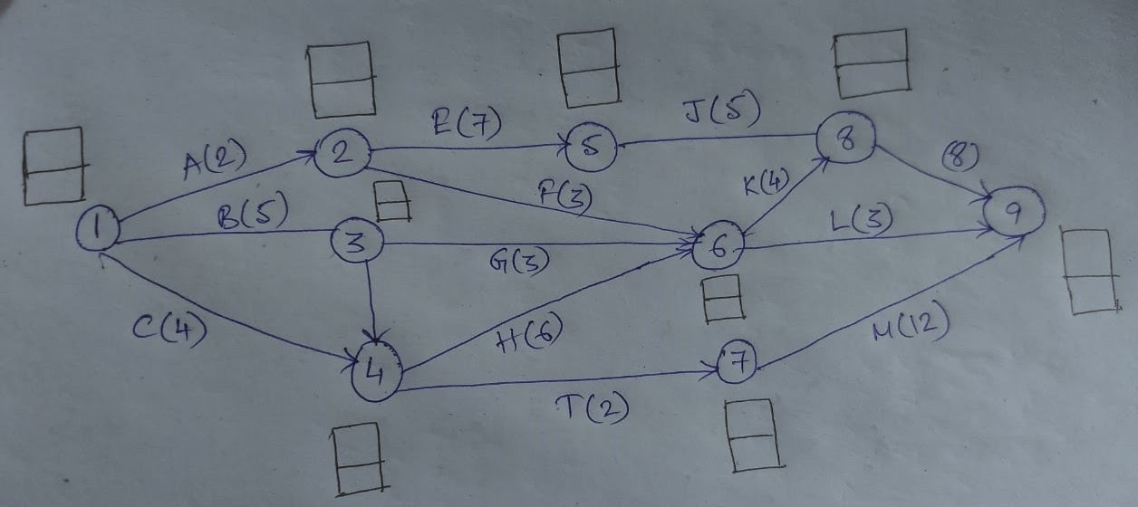

For node 1 Earliest time = 0  
For node 2 Earliest time = 2  
For node 3 Earliest time = 5  
For node 4 Earliest time = 4  
For node 5 Earliest time = 9  
For node 6 Earliest time = 10  
For node 7 Earliest time = 6  
For node 8 Earliest time = 14  
For node 9 Earliest time = 22

1. What do you mean by forward pass?

The forward pass is a technique to move forward through network diagram to determine the project duration and finding the critical path or free float of the project.